Assignment 5

Q1 Display highest,lowest,sum,average salary of all employees. Label columns as maximum

,minimum,Sum,Average respectively.Round your results to your nearest whole number.

select round(max(salary)) as maximum,round(min(salary)) as minimum,round(sum(salary)) as sum, round(avg(salary)) as average from employees;

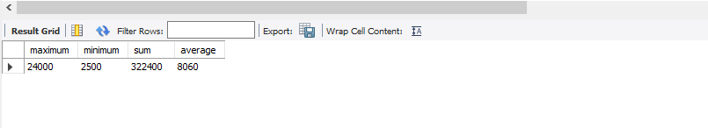

Q2. Add a column as job id for table employee.Add the values.

Q3. Modify the query in Q1,display maximum,minimum,average salaries for the job ids.

select (max(salary)) as maximum,(min(salary)) as minimum,(avg(salary)) as average from employees group by job_id;

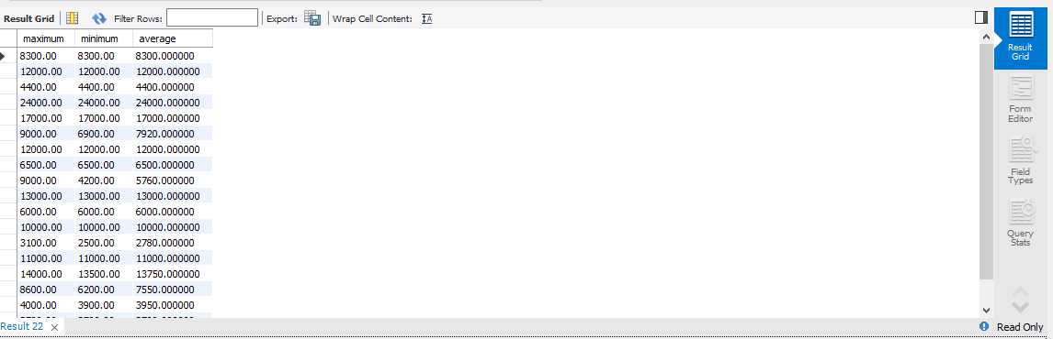

Q4. Write a query to display the number of people with same salary.

Q5. Determine the number of managers without listing them. Label columns as “Number Of Managers”.

select count(manager_id) as Number_Of_Managers from employees;

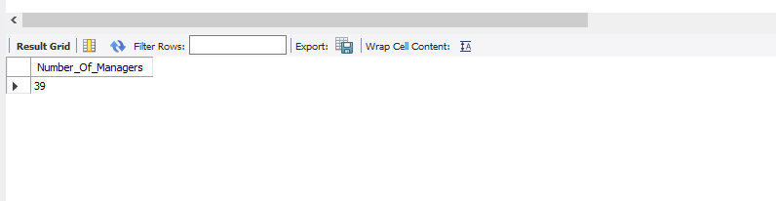

Q6. Write a query that displays the difference between the highest and lowest salaries. Label column as

DIFFERENCE.

Q7. Display the salary of lowest paid employee .Exclude any groups where minimum salary is less than

$10000.Sort the output in descending order of salary.

Q8. Write a query to display the last name and hiredate of any employee in same department.

Q9. Create a query to display the employee numbers and last names of all employees who earn more

than the average salaries.Sort the results in ascending order of salary.

Q10. Write a query that displays the employee numbers and last names of all employees who work in a department with any employee whose last name contains a u.